**Kenna’s Fight**

** Presenting - $750**

Event Naming Rights

Option for opening remarks during ceremony before candle lighting

Event day tend (10x10) with samples/literature with approval

10 tickets into the concert

Recognition on all event signage and advertisements



** Volunteer Table - $400**

Event day tent (10x10) with samples/literature with approval

6 tickets into the concert

Recognition on signage at registration table and advertisements



** Front Gate - $250**

Event day tent (10x10) with samples/literature

with approval

4 tickets into the concert

Recognition signage at Front gate and advertisement

** Welcome Signs - $200**

2 tickets into the concert

Recognition signage on Welcome sign and advertisement

**\*\*There can be multiple Businesses for each sponsor level\*\***

**Benefit Concert**

You are not alone… Speak up & Reach out



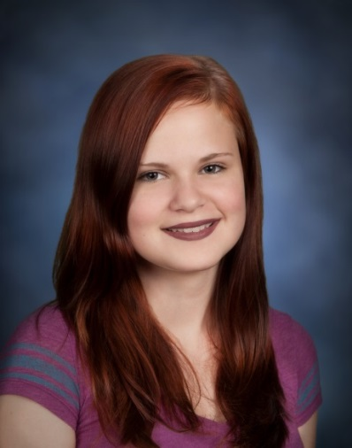

**August 29, 2020**

**Nashville’s in Henrietta**

Business Name: __________________________________________

Contact Name:___________________________________________

Address:________________________________________________

City/State/Zip:___________________________________________

Phone:_________________________________________________

Email:__________________________________________________

**Payment Information**

**Donation Amount $___________________________________________**

 Check Enclosed  Credit Card  Cash

**Designate my sponsorship to:**

 Strong Hospital Pediatric Behavioral Health & Wellness Center

Bring awareness to teen suicide in the Rochester Area



**Make checks out to Makenna R. Dadey Memorial Fund.**

**If paying with a Credit Card please use PayPal**

**Account is** [**kennamemorialfund@hotmail.com**](mailto:kennamemorialfund@hotmail.com)

**Please email this completed form and your company logo as a vector**

**ESP/AI/PDF (preferred), high-res PDF or high-res JPG to**

[**pdadey@rochester.rr.com**](mailto:pdadey@rochester.rr.com)

**Questions?** Please contact Patrick J. Dadey at **(585) 414-7000**

1 1239 Howard Road, Rochester, New York 14624

**IRS Tax ID #82-0748586**